October 4, 2024

New Delhi, India



Data manager GUIDE

*EmpowerU Data manger*

Table of Contents

Introduction 2

Chapter 1 - Login 3

Chapter 2 - SUMMARY 4

Chapter 3 - AREA 5

3.1 Export Area 5

3.2 Import Area 7

3.3 Add Area 7

Chapter 4 – CLASSIFICATION 9

Chapter 5 – PROGRAM CYCLE 11

Chapter 5 – RESOURCE 13

Chapter 6 – IMPORT LOG 15

Chapter 7 – USER 16

Chapter 8 – KEYFACTS 18

# Introduction

This user manual is developed to help the data administrators to understand the use of Data Manager application and its modules. This application will only be accessed to the users with valid login credentials.

The Data Manager application comprises of various data management modules. These modules allow the creation and management of the data and their elements.

**NOTE:** Valid login credentials are required to access the Data Manager application.

The Data Manager application contains the following modules -

* Summary
* Area
* Classification
* Program Cycle
* Access Control
* Report
* Resource
* Keyfacts

Each of these modules are explained in detail in the following chapters

# LOGIN

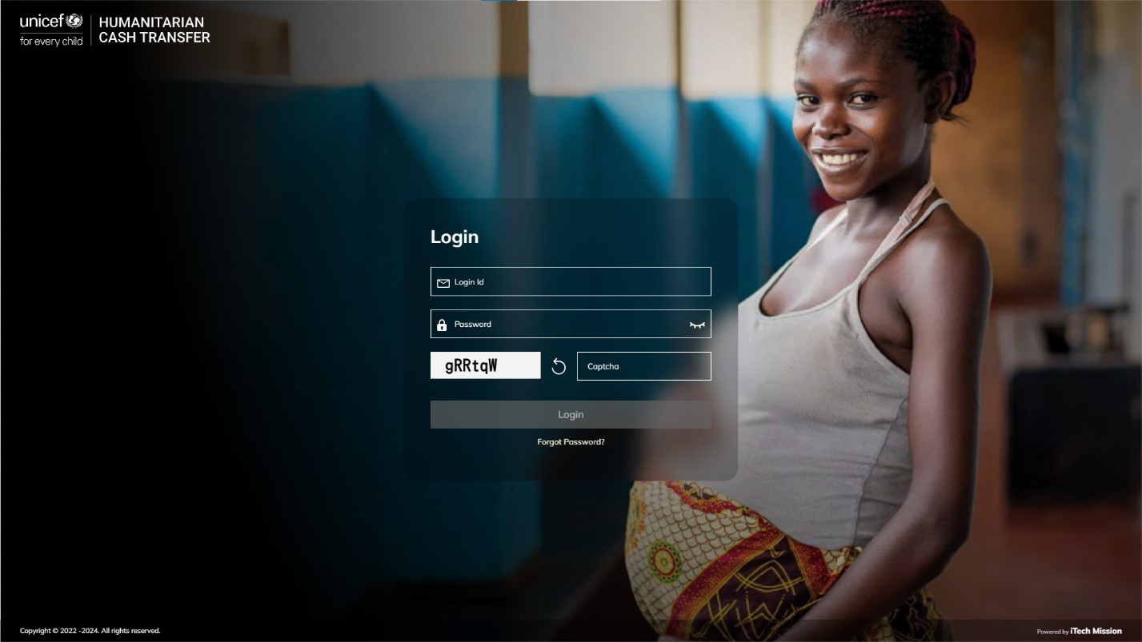The Data Manager application can be accessed through a web browser. While the application is cross browser compatible, Google Chrome latest version is recommended browser for better experience. Enter the following URL <https://empoweru.itechmission.org/datamanager/> in the web browser. You will land on the login page of the data manager application. In the login panel enter the email and password with a valid captcha. Click on the Login button to validate (see below figure).

# Chapter 2 - SUMMARY

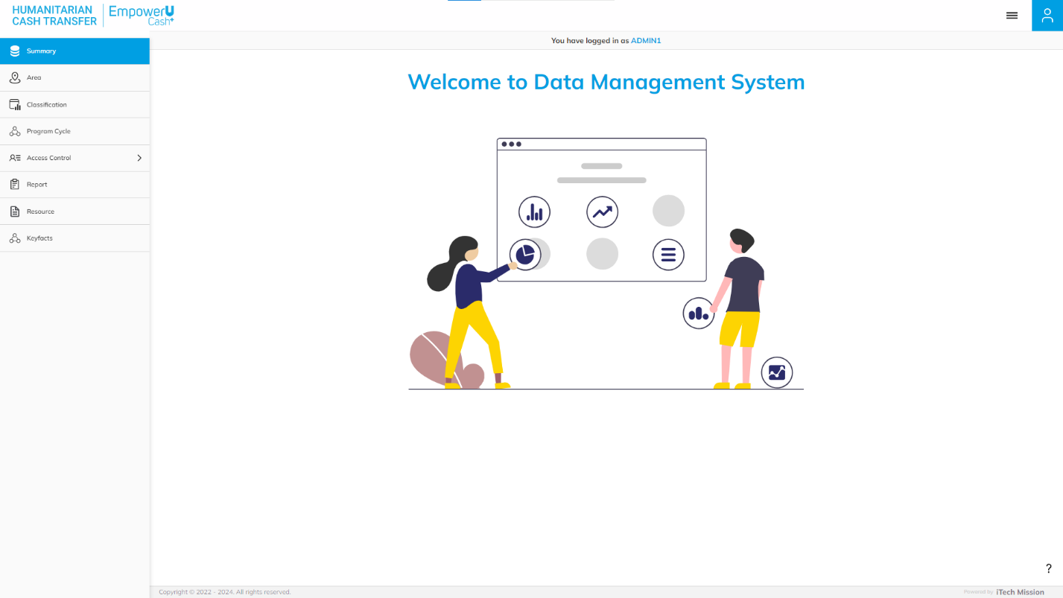The first module after successful login is **Summary**. You can also access this module by clicking on the Summary option in the left panel. This module depicts the following information of the database.

# Chapter 3 - AREA

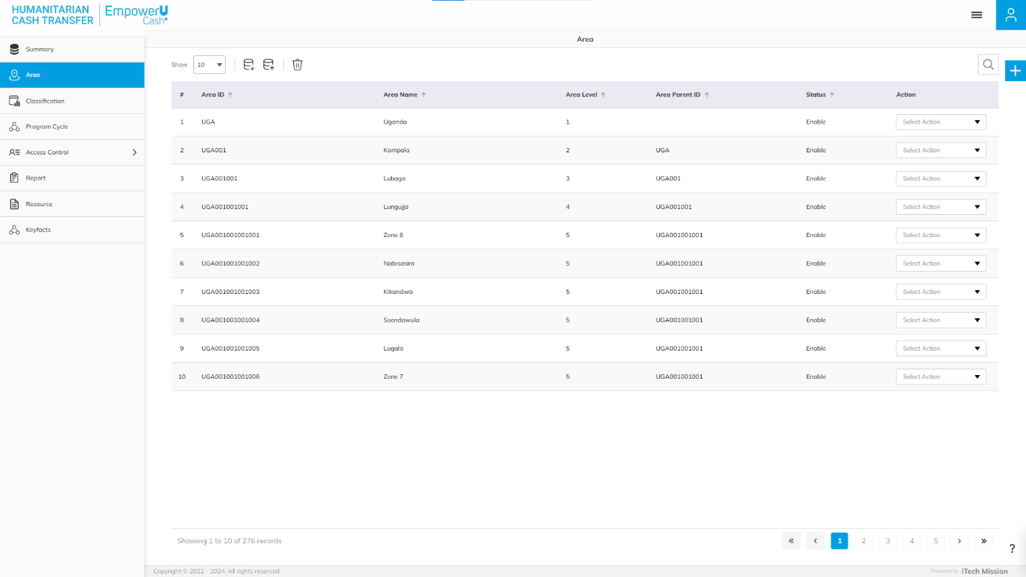Click on the **Area** option in the left panel to access this module. This module allows to manage the area master list. You will have options to export and import an area template, add new area, view the list of existing areas, sort the list, search area from the list, edit and show/hide existing areas (see below figure).

## 3.1 Export Area

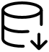Click on the **Export** button to download the empty area template and the area master list available in the database. You can use this option to create an area structure. Below is the area structure that you will find in the area template.

|  |  |
| --- | --- |
| **AreaID** | A unique area identification that associates the area to its map. |
| **AreaName** | Area Name assigned to an area. |
| **AreaLevel** | The level number assigned in the area hierarchy. |
| **AreaParentID** | AreaID of the parent area. |
| **Area Group** | Group of the area. |

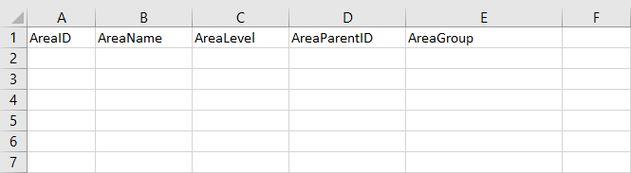Click on the **Empty** option to download an empty area template. The area list is imported and exported in the CSV (Comma Separated Value) file format.

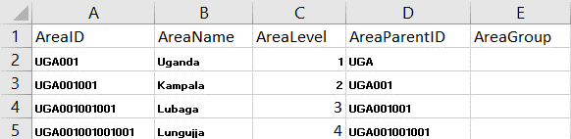Click on the **With Data** option to download the area master list

## 3.2 Import Area

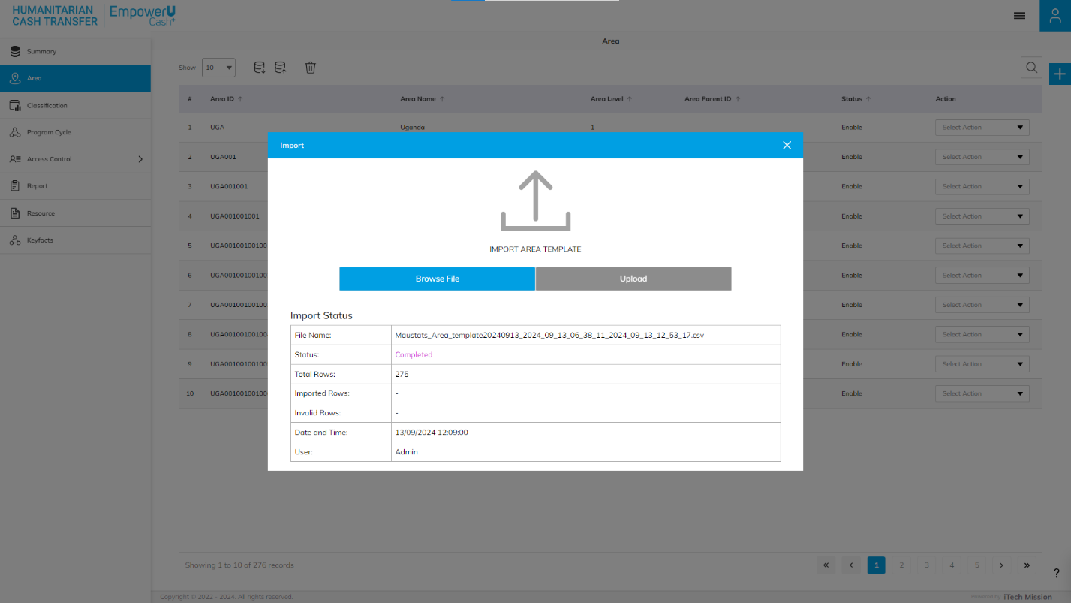Click on the **Import** button to browse the file and upload the area master list into the database. To upload the area into the database, first enter the area structure in the template as explained above and then click on the **Browse File** button to select the template. Now, click on the Upload button to start the import process.

During the import process, the records which contains blank entries, entries with special characters and duplicate entries are not imported in the database. A Last Upload summary will appear after the import process which provides the count of successfully imported records out of the total records. An error log will be generated to report on unsuccessful imported records which you can access from Import Log module.

## 3.3 Add Area

Click on the **Plus** button available to the right side of the page to add a new area. Enter the following details to add a new area.

* Enter Name
* Select Parent Area (In case child area is added)
* Enter Area ID

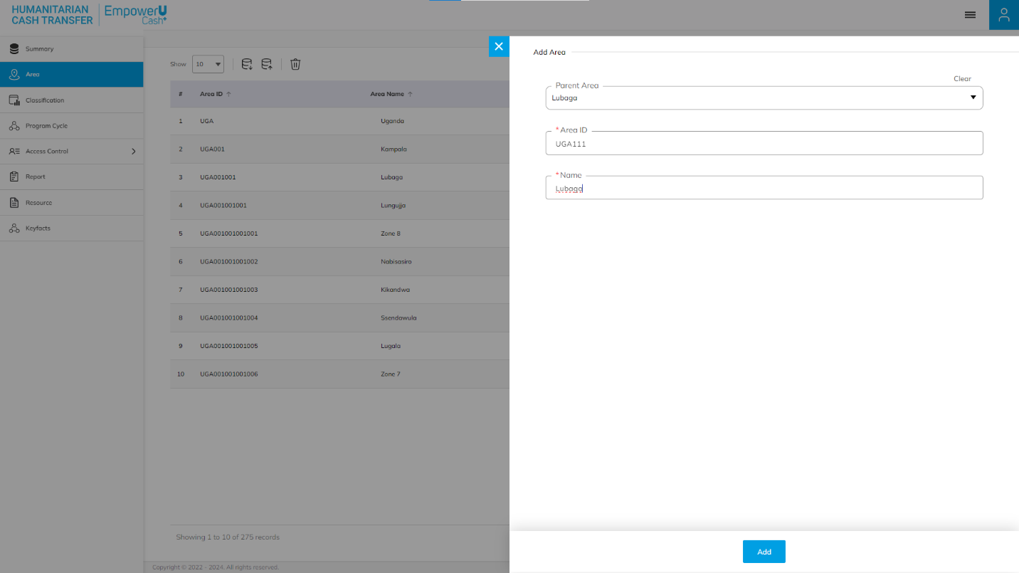All details are mandatory to be entered. Click on the **Add** button to save and confirm. You can now view the new area added in the area list.

Click on the **Edit** option available in the action column to edit the details of the selected area. Edit the required detail and click on update button to save and confirm.

Click to on the **Enable/Disable** option available in the action column to show or hide the specific area. The hidden area will not be shown in the list of area throughout the application.

Click to on the **Delete** option available in the action column to delete the specific area. The deleted area will not be shown in the list of area throughout the application.

# Chapter 4 – CLASSIFICATION

Click on the **Classification** option in the left panel to access this module. This module allows to manage the master list of classification You will have options to add new classification for the selected classification type, view the list of classification, sort the list, search classification from the list, edit a classification.

Select Classification type. Click on the **Plus** button available to the right side of the page to add a new classification for the selected classification type. Enter the following details for the same.

* Classification Name

All the above details are mandatory to be entered. Click on the **Add** button to save and confirm. You can now view the new classification added to the list.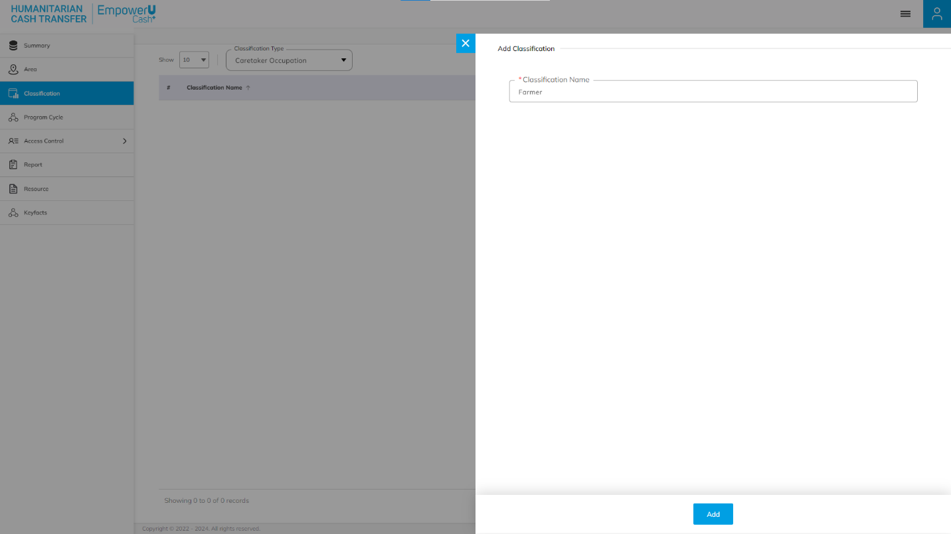

Click on the **Edit** option available in the action column to edit the details of the selected classification. Edit the required detail and click on **Update** button to save and confirm.

Click to on the **Enable/Disable** option available in the action column to show or hide the specific data source. The hidden classification will not be shown in the list of classification throughout the application

Click to on the **Delete** option available in the action column to delete the specific classification. The deleted classification will not be shown in the list of program cycle throughout the application.

# Chapter 5 – PROGRAM CYCLE

Click on the **Program Cycle** option from the left panel to access this module. This module allows to manage the master list of program cycles. You will have options to add a new Program Cycle, view the list of existing Program Cycle, sort the list, search Program Cycle from the list and edit an existing Program Cycle.

Click on the **Plus** button available to the right side of the page to add a new program cycle. Enter the following details for the same.

* Enter Name
* Enter Description
* Enter Start Date
* Enter End Date
* Enter Child per household
* Enter Total amount allotted
* Enter Amount per child
* Enter Installment 1
* Enter Installment 2
* Enter Installment 3
* Enter Saving Installment

Click on the **Add** button to save and confirm. You can now view the new program cycle added to the list

Click on the **Edit** option available in the action column to edit the selected time period and click on **Update** button to save and confirm 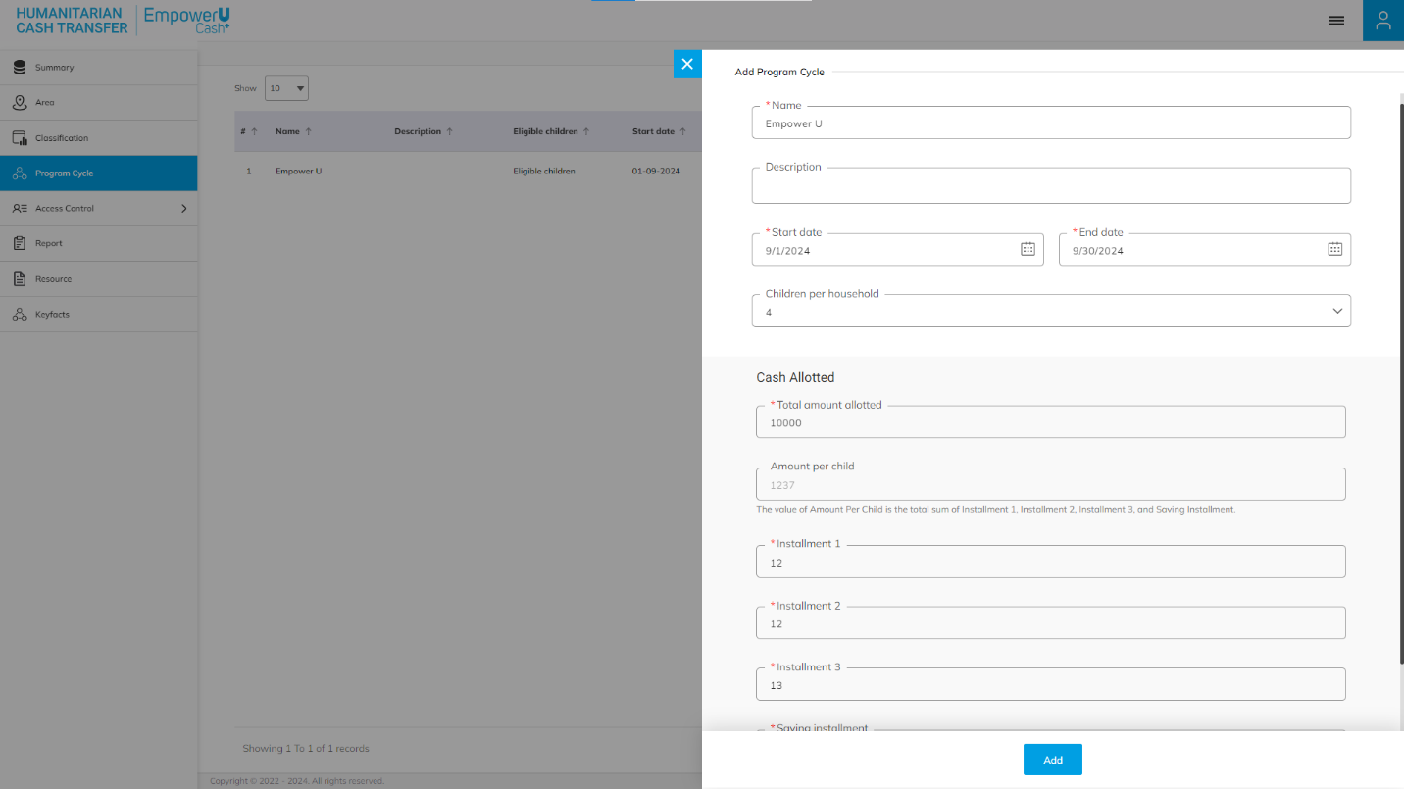

Click to on the **Enable/Disable** option available in the action column to show or hide the specific data source. The hidden program cycle will not be shown in the list of program cycle throughout the application.

Click to on the **Delete** option available in the action column to delete the specific data source. The deleted program cycle will not be shown in the list of program cycle throughout the application.

# Chapter 5 – RESOURCE

Click on the **Resource** option from the left panel to access this module. This module allows to manage the master list of resources. You will have options to add a new resource, view the list of existing resources, sort the list, search resources from the list and edit an existing resource.

Click on the **Plus** button available to the right side of the page to add a new resource. Enter the following details for the same.

* Enter Resource Name
* Enter Resource Description
* Enter Resource Type (Link, Document)
* Enter Insert (Url / pdf)
* Enter Category
* Enter Image (upload jpeg)

Click on the **Add** button to save and confirm. You can now view the new resource added to the list

Click on the **Edit** option available in the action column to edit the selected time period and click on **Update** button to save and confirm

Click to on the **Enable/Disable** option available in the action column to show or hide the specific data source. The hidden program cycle will not be shown in the list of program cycle throughout the application.

Click to on the **Delete** option available in the action column to delete the specific resource. The deleted resource will not be shown in the list of resource throughout the application.

# Chapter 6 – IMPORT LOG

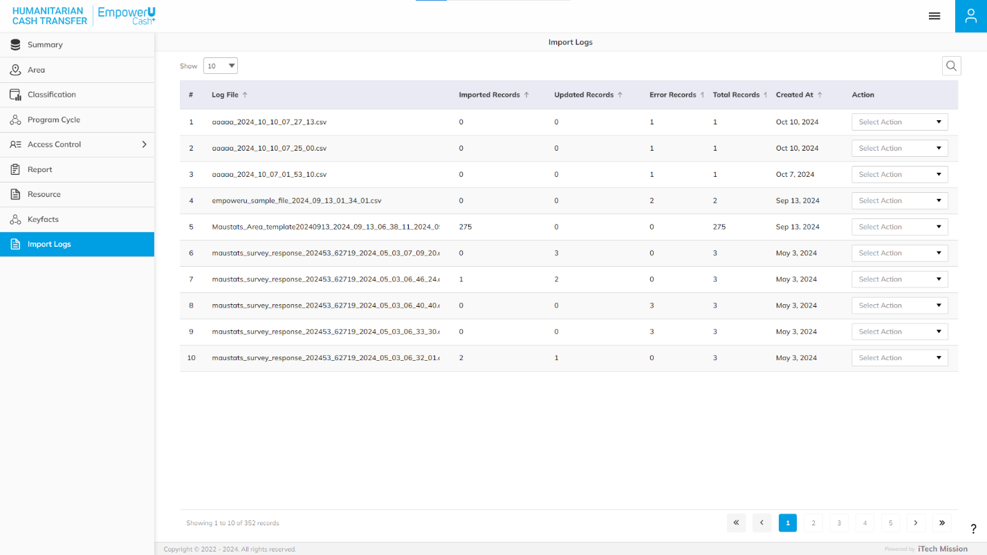Click on the **Import** **Log** option from the Data Management menu option in the left panel to access this module. This module allows to manage the Import Log master list. You will have options to view the list of existing logs, download and view log reports and delete selected log (see below figure).

A log will be generated when any data template is imported into the database. A list of import logs is shown on this page where each import log is shown as a row. You can view the file name of each import log along with the log summary that includes: count of records imported, count of records updated, count of error records, total records available in the import file and date & time of the import.

Click on the **Download** option available in the action column to download the log file and view the reason of error records. The log file will be downloaded in CSV format.

Click on the **Delete** option available in the action column to delete the selected record from the tabular grid.

# Chapter 7 – USER

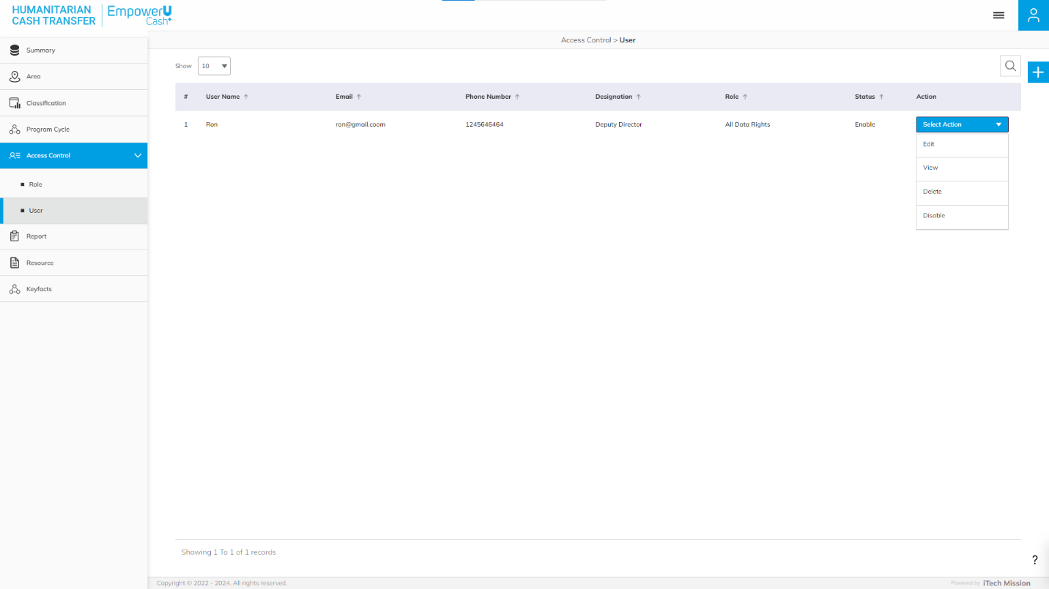Click on the **User** option from the access control menu option in the left panel to access this module. This module allows to manage the User master list. You will have options to add new users, view the list of existing users, search users from the list, edit and Show/Hide existing users (see figure below).

Click on the **Plus** button available to the right side of the page to add new user. Enter the following details to create a new user.

* Enter User Name
* Enter Email
* Enter Phone Number
* Select Designation(Deputy Director, Director, Principal Statistician, etc.)
* Select Role (All Data Rights, Analyst, Census Analyst)
* Set Password

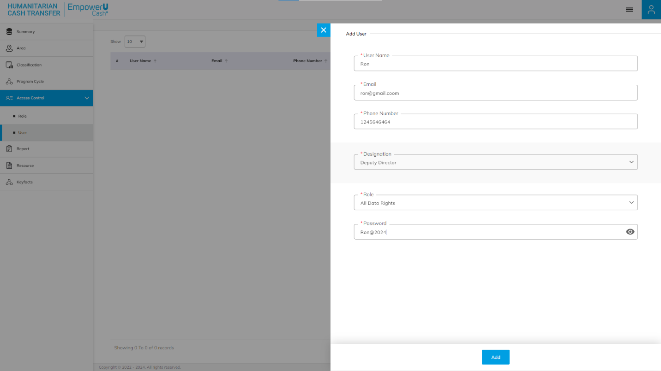All the above details are mandatory to be entered. Click on the **Add** button to save and confirm. You can now view the new user added in the list.

Click on the **Edit** option available in the action column to edit the details of the selected user. Edit the required detail and click on **Update** button to save and confirm.

Click on the **Enable/Disable** option available in the action column to active or inactive the selected user. The inactive user will not be able login into the application.

Click to on the **Delete** option available in the action column to delete the specific user. The deleted user will not be shown in the list of user throughout the application

# Chapter 8 – KEYFACTS

Click on the **Keyfacts** option in the left panel to access this module. This module allows to manage the master list of keyfacts You will have options to add new keyfact, view the list of keyfact, sort the list, search keyfact from the list, edit a keyfact.

Click on the **Plus** button available to the right side of the page to add a new classification for the selected classification type. Enter the following details for the same.

* Enter Text
* Select Unit (Number /Percent)
* Enter Value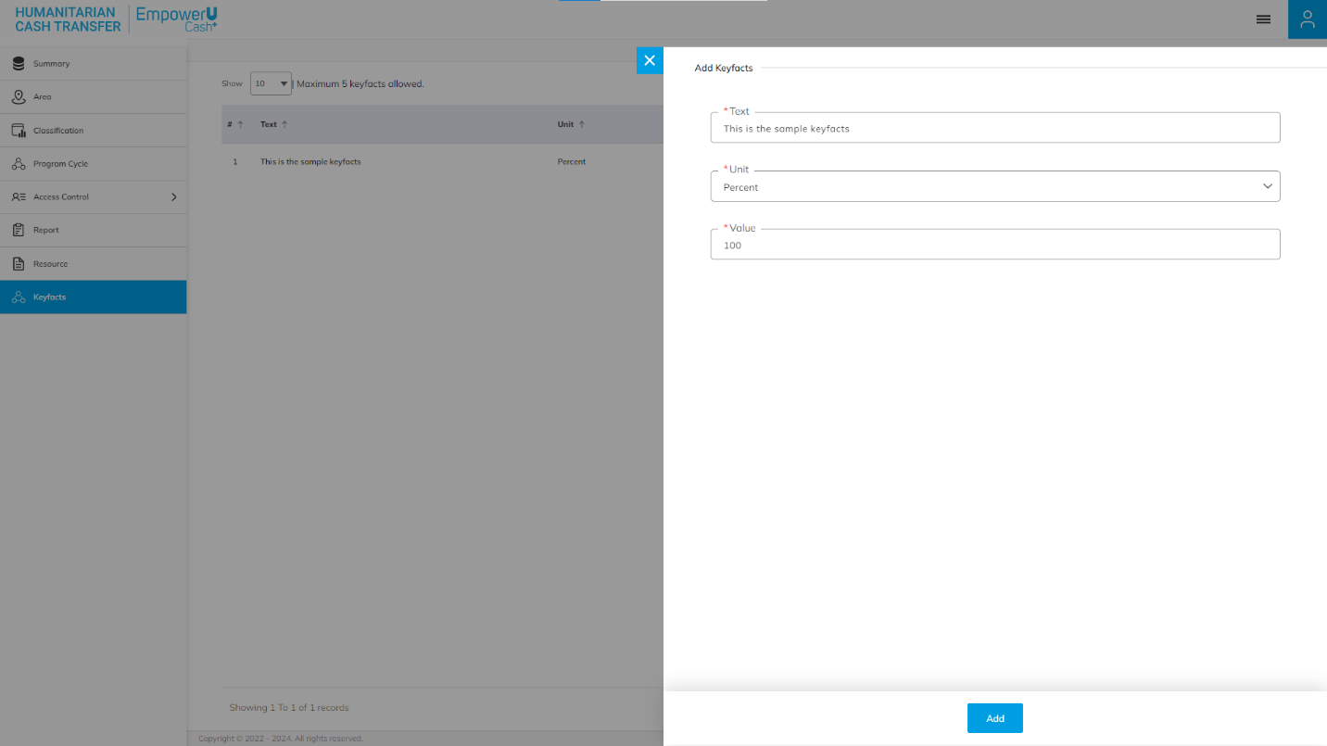
* All details are mandatory to be entered. Click on the **Add** button to save and confirm. You can now view the new keyfact added in the area list.
* Click on the **Edit** option available in the action column to edit the details of the selected keyfact. Edit the required detail and click on update button to save and confirm.
* Click to on the **Enable/Disable** option available in the action column to show or hide the specific keyfact. The hidden area will not be shown in the list of area throughout the application.
* Click to on the **Delete** option available in the action column to delete the specific area. The deleted area will not be shown in the list of keyfact throughout the application.

--- End of the document --